**DBCA configuration**

**รูปภาพประกอบด้วย ข้อความ

คำอธิบายที่สร้างโดยอัตโนมัติ**

**รูปภาพประกอบด้วย ข้อความ

คำอธิบายที่สร้างโดยอัตโนมัติ**

**รูปภาพประกอบด้วย ข้อความ

คำอธิบายที่สร้างโดยอัตโนมัติ**

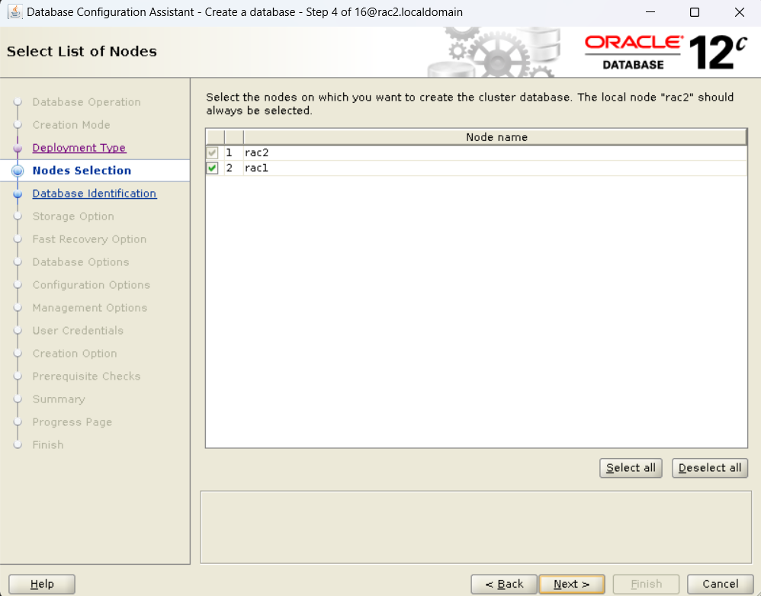

**รูปภาพประกอบด้วย ข้อความ

คำอธิบายที่สร้างโดยอัตโนมัติ**

**รูปภาพประกอบด้วย ข้อความ

คำอธิบายที่สร้างโดยอัตโนมัติ**

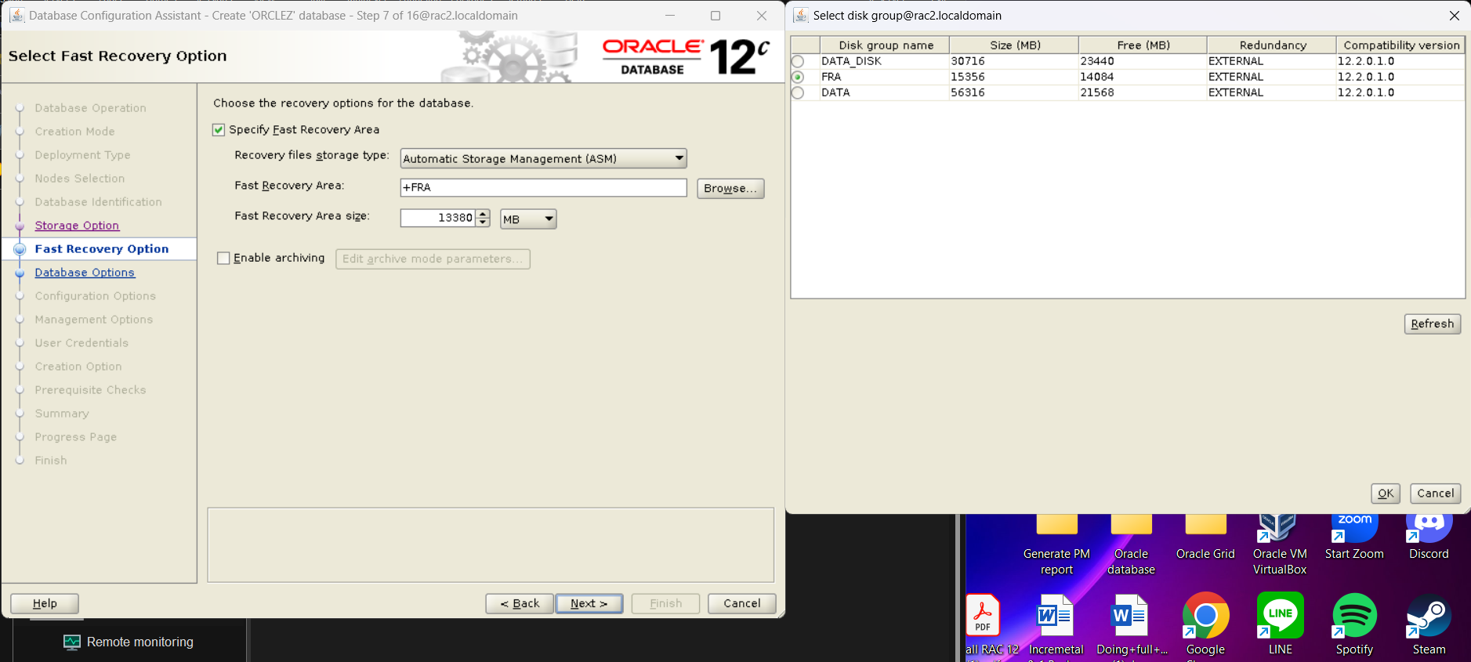

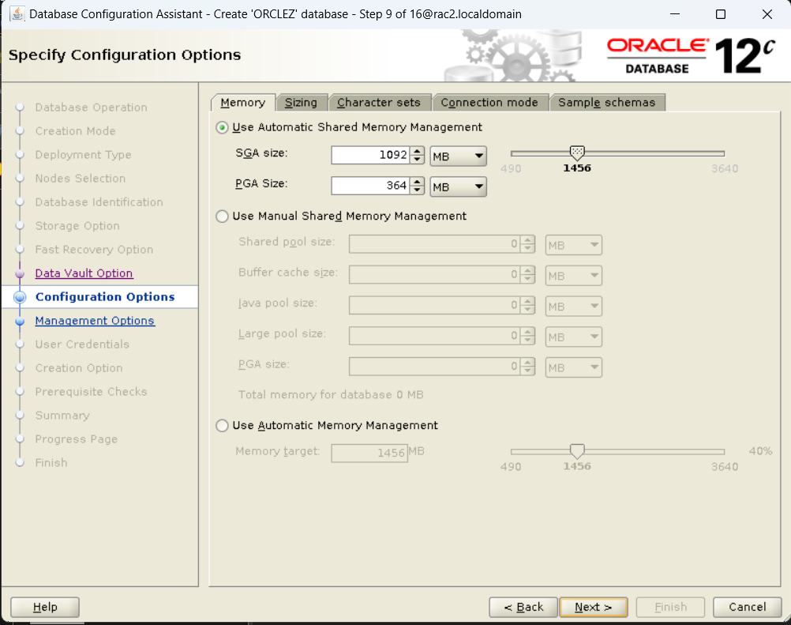

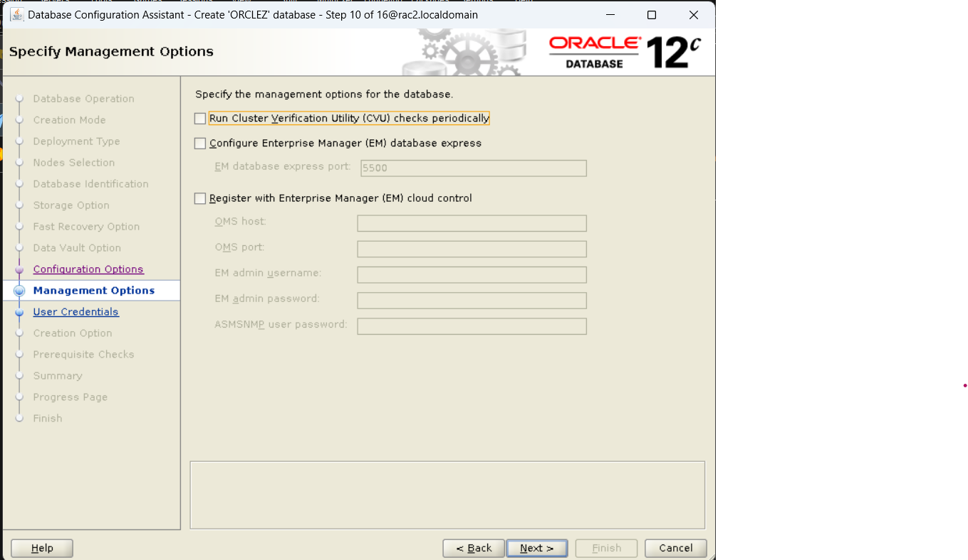

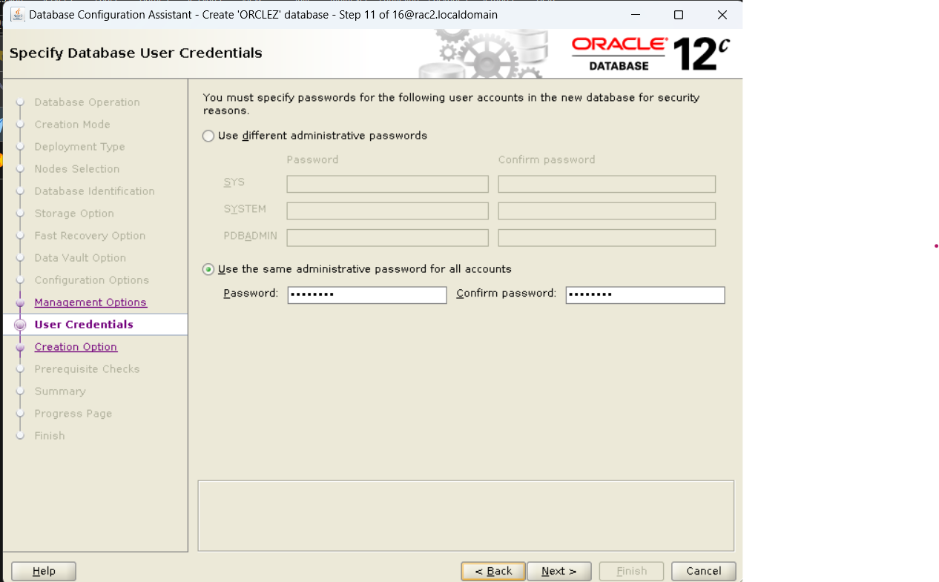

**รูปภาพประกอบด้วย ข้อความ

คำอธิบายที่สร้างโดยอัตโนมัติ**

**รูปภาพประกอบด้วย ข้อความ

คำอธิบายที่สร้างโดยอัตโนมัติ**

**รูปภาพประกอบด้วย ข้อความ

คำอธิบายที่สร้างโดยอัตโนมัติ**

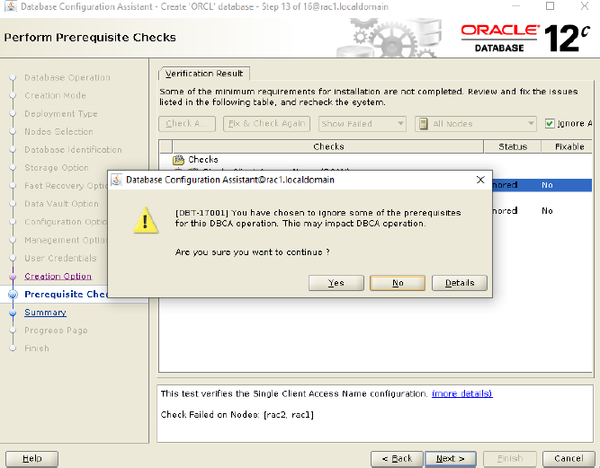

**รูปภาพประกอบด้วย ข้อความ

คำอธิบายที่สร้างโดยอัตโนมัติ**

**รูปภาพประกอบด้วย ข้อความ

คำอธิบายที่สร้างโดยอัตโนมัติ**

**Configure parameter, log-destination**

|  |  |  |  |  |  |
| --- | --- | --- | --- | --- | --- |
| **No.** | **USER** | **SID** |  | **Command** | **Status** |
| 1 | ORACLE | ORCL1 | $ | echo $ORACLE_SID | ORCL1 |
| 2 | ORACLE | ORCL1 | $ | sqlplus / as sysdba |  |
| 3 | ORACLE | ORCL1 | SQL> | show pdbs | CDB open PDB mounted |
| 4 | ORACLE | ORCL1 | SQL> | archive log list | Disabled |
| 5 | ORACLE | ORCL1 | SQL> | show parameter db_recovery_file_dest |  |
| 6 | ORACLE | ORCL1 | SQL> | select dest_name, status, destination from v$archive_dest; | LOG_ARCHIVE_DEST_1 VALID USE_DB_RECOVERY_FILE_DEST |
| 7 | ORACLE | ORCL1 | SQL> | exit |  |
| 8 | ORACLE | ORCL1 | $ | rman target=/ |  |
| 9 | ORACLE | ORCL1 | RMAN> | show all; |  |
| 0 | ORACLE | ORCL1 | RMAN> | configure controlfile autobackup format for device type disk to '+DATA_DISK'; |  |
| 11 | ORACLE | ORCL1 | RMAN> | shutdown immediate | database closed database dismounted Oracle instance shutdown |
| 12 | ORACLE | ORCL1 | RMAN> | startup mount | connected to target database (not started) Oracle instance started database mounted |
| 13 | ORACLE | ORCL2 | $ | echo $ORACLE_SID | ORCL2 |
| 14 | ORACLE | ORCL2 | $ | sqlplus / as sysdba |  |
| 15 | ORACLE | ORCL2 | SQL> | show pdbs | CDB open PDB open |
| 16 | ORACLE | ORCL2 | SQL> | shutdown immediate | database closed database dismounted Oracle instance shutdown |
| 17 | ORACLE | ORCL2 | SQL> | startup mount | connected to target database (not started) Oracle instance started database mounted |
| 18 | ORACLE | ORCL1 | RMAN> | alter database archivelog; | Statement processed |
| 19 | ORACLE | ORCL1 | RMAN> | exit |  |
| 20 | ORACLE | ORCL1 | $ | sqlplus / as sysdba |  |
| 21 | ORACLE | ORCL1 | SQL> | show pdbs | CDB mounted PDB mounted |
| 22 | ORACLE | ORCL1 | SQL> | archive log list | Enabled |

**อธิบายเพิ่มเติม:**

1. เช็คว่า Automatic Archive log mode เป็น Enabled หรือยัง
   * $> sqlplus / as sysdba
     + sql> show pdbs (เพื่อดูสถานะของ CDBและPDB)
     + sql> show con_name
       - (ดูชื่อ container name)
     + sql> archive log list
       - เช็คว่า Archive log mode เป็น Enabled หรือยัง
       - เช็คว่า Archive destination ขึ้นไปเก็บที่ ASM Disk หรือยัง   
           
         ถ้าไม่ได้ตั้งเป็น fast recovery area ตั้งแต่ตอน setting dbca ตอนแรกปกติมันจะส่งไปที่ file system
2. เช็ค Archive destination
   * Sql> show parameter db_recovery_file_dest
     + กรณีที่เรา set fast recovery area แล้วมันจะมีค่าในตาราง
     + รูปภาพประกอบด้วย ข้อความ

       คำอธิบายที่สร้างโดยอัตโนมัติ
   * Sql> select dest_name, status, destination from v$archive_dest;
     + จาก <<https://www.dba-oracle.com/t_find_oracle_archive_logs.htm>>
     + จะเห็นได้ว่า ในส่วนของ log_archive_dest_1 มีค่าเป็น +DATA_DISK/orcl แล้วเนื่องจาก ก่อนหน้านี้ผมได้ทำการ configure ให้ archive destination ไปอยู่บน ASM Disk ตาม path ดังกล่าวแล้ว !!
     + รูปภาพประกอบด้วย ตาราง

       คำอธิบายที่สร้างโดยอัตโนมัติ
   * ถ้า log_archive_dest_1 ยังมี destination เป็น file system อยู่ ให้ (ทำข้อ 3) !!!   
     NOTE: log_archive_dest_1 ห้ามเหมือน log_archive_dest_2 เดี๋ยว spfile เจ๊งแล้วเปิดใช้ database ไม่ได้!   
     (อาจจะมีวิธีแก้ แต่ยังทำไม่เป็น)
3. Configure archive log destination.
   * Sql> alter system set log_archive_dest_1 ='Location=+DATA_DISK/orcl' scope=both;
   * เสร็จแล้วเช็ค archive log list ว่าเปลี่ยนแล้ววจริงมั้ยใน (ข้อที่ 2 ซ้ำอีกครั้ง)

1. เข้า RMAN แล้วไปเช็คค่า default ของ configuration เพื่อตรวจดูว่า control file ปกติ auto backup ไว้ที่ ASM Disk หรือยัง ->> ปกติจะจัดเก็บที่ file system จงต้องแก้ไขเอาไปไว้ที่ ASM disk
   * $> rman target=/
     + RMAN> show all;
       - เพื่อเช็คค่า default ของ configuration
     + RMAN> CONFIGURE CONTROLFILE AUTOBACKUP FORMAT FOR DEVICE TYPE DISK TO '+DATA_DISK';
       - configure ให้ control file autobackup ขึ้นไปที่ ASM DISK;
2. **Insert ข้อมูลลง table emp ที่มีอยู่แล้ว**

**[oracle@rac1 ~]$ sqlplus / as sysdba**

SQL*Plus: Release 12.2.0.1.0 Production on Wed Feb 15 14:33:11 2023

Copyright (c) 1982, 2016, Oracle. All rights reserved.

Connected to:

Oracle Database 12c Enterprise Edition Release 12.2.0.1.0 - 64bit Production

**SQL> show pdbs;**

CON_ID CON_NAME OPEN MODE RESTRICTED

---------- ------------------------------ ---------- ----------

2 PDB$SEED READ ONLY NO

3 ORCLPDB MOUNTED

**SQL> select * from emp;**

NAME

--------------------------------------------------------------------------------

JAMES

JAMES2

**SQL> insert into emp values ('JAMES3');**

1 row created.

**SQL> commit;**

Commit complete.

**SQL> select to_char(sysdate,'YYYY-MM-DD:HH24:MI:SS') time_now from dual;**

**TIME_NOW**

**-------------------**

**2023-02-15:14:34:32**

**SQL> exit**

Disconnected from Oracle Database 12c Enterprise Edition Release 12.2.0.1.0 - 64bit Production

1. **เข้า RMAN เพื่อทำการ backup incremental level 0 ข้อมูลหลังจาก Insert ข้อมูลลง table emp**

**[oracle@rac1 ~]$ rman target=/**

Recovery Manager: Release 12.2.0.1.0 - Production on Wed Feb 15 14:35:10 2023

Copyright (c) 1982, 2017, Oracle and/or its affiliates. All rights reserved.

connected to target database: ORCL (DBID=1656638733)

**RMAN> shutdown immediate;**

using target database control file instead of recovery catalog

database closed

database dismounted

Oracle instance shut down

**RMAN> startup mount;**

connected to target database (not started)

Oracle instance started

database mounted

Total System Global Area 1157627904 bytes

Fixed Size 8792008 bytes

Variable Size 503318584 bytes

Database Buffers 637534208 bytes

Redo Buffers 7983104 bytes

**RMAN> backup incremental level 0 database plus archivelog TAG LV0;**

Starting backup at 15-FEB-23

allocated channel: ORA_DISK_1

channel ORA_DISK_1: SID=61 instance=ORCL1 device type=DISK

channel ORA_DISK_1: starting archived log backup set

channel ORA_DISK_1: specifying archived log(s) in backup set

input archived log thread=1 sequence=2 RECID=2 STAMP=1128862835

input archived log thread=2 sequence=1 RECID=1 STAMP=1128862835

input archived log thread=2 sequence=2 RECID=3 STAMP=1128862856

input archived log thread=1 sequence=3 RECID=4 STAMP=1128862858

input archived log thread=2 sequence=3 RECID=5 STAMP=1128862920

input archived log thread=1 sequence=4 RECID=6 STAMP=1128862921

input archived log thread=2 sequence=4 RECID=10 STAMP=1128866816

input archived log thread=1 sequence=5 RECID=7 STAMP=1128863980

input archived log thread=1 sequence=6 RECID=8 STAMP=1128864909

input archived log thread=1 sequence=7 RECID=9 STAMP=1128865932

input archived log thread=1 sequence=8 RECID=13 STAMP=1128867217

input archived log thread=2 sequence=5 RECID=11 STAMP=1128866865

input archived log thread=2 sequence=6 RECID=12 STAMP=1128867216

input archived log thread=2 sequence=7 RECID=14 STAMP=1128867226

input archived log thread=1 sequence=9 RECID=15 STAMP=1128867226

input archived log thread=2 sequence=8 RECID=16 STAMP=1128867273

input archived log thread=1 sequence=10 RECID=17 STAMP=1128867273

input archived log thread=2 sequence=9 RECID=18 STAMP=1128867279

input archived log thread=1 sequence=11 RECID=19 STAMP=1128867279

input archived log thread=2 sequence=10 RECID=21 STAMP=1128868272

input archived log thread=1 sequence=12 RECID=20 STAMP=1128867971

input archived log thread=1 sequence=13 RECID=23 STAMP=1128868533

input archived log thread=2 sequence=11 RECID=22 STAMP=1128868425

channel ORA_DISK_1: starting piece 1 at 15-FEB-23

channel ORA_DISK_1: finished piece 1 at 15-FEB-23

piece handle=+FRA/ORCL/BACKUPSET/2023_02_15/annnf0_lv0_0.285.1128868601 tag=LV0 comment=NONE

channel ORA_DISK_1: backup set complete, elapsed time: 00:00:01

Finished backup at 15-FEB-23

Starting backup at 15-FEB-23

using channel ORA_DISK_1

**channel ORA_DISK_1: starting incremental level 0 datafile backup set**

channel ORA_DISK_1: specifying datafile(s) in backup set

input datafile file number=00001 name=+DATA_DISK/ORCL/DATAFILE/system.270.1128857845

input datafile file number=00003 name=+DATA_DISK/ORCL/DATAFILE/sysaux.297.1128857887

input datafile file number=00004 name=+DATA_DISK/ORCL/DATAFILE/undotbs1.256.1128857931

input datafile file number=00009 name=+DATA_DISK/ORCL/DATAFILE/undotbs2.267.1128858253

input datafile file number=00007 name=+DATA_DISK/ORCL/DATAFILE/users.313.1128857935

channel ORA_DISK_1: starting piece 1 at 15-FEB-23

channel ORA_DISK_1: finished piece 1 at 15-FEB-23

piece handle=+FRA/ORCL/BACKUPSET/2023_02_15/nnndn0_**tag20230215t143641**_0.286.1128868603 tag=**TAG20230215T143641** comment=NONE

channel ORA_DISK_1: backup set complete, elapsed time: 00:00:07

channel ORA_DISK_1: starting incremental level 0 datafile backup set

channel ORA_DISK_1: specifying datafile(s) in backup set

input datafile file number=00011 name=+DATA_DISK/ORCL/F4B6CEE5CF3053C7E0530118A8C02091/DATAFILE/sysaux.405.1128858 589

input datafile file number=00010 name=+DATA_DISK/ORCL/F4B6CEE5CF3053C7E0530118A8C02091/DATAFILE/system.408.1128858 589

input datafile file number=00012 name=+DATA_DISK/ORCL/F4B6CEE5CF3053C7E0530118A8C02091/DATAFILE/undotbs1.411.11288 58589

input datafile file number=00013 name=+DATA_DISK/ORCL/F4B6CEE5CF3053C7E0530118A8C02091/DATAFILE/undo_2.399.1128858 645

input datafile file number=00014 name=+DATA_DISK/ORCL/F4B6CEE5CF3053C7E0530118A8C02091/DATAFILE/users.394.11288586 49

channel ORA_DISK_1: starting piece 1 at 15-FEB-23

channel ORA_DISK_1: finished piece 1 at 15-FEB-23

piece handle=+FRA/ORCL/F4B6CEE5CF3053C7E0530118A8C02091/BACKUPSET/2023_02_15/nnndn0_tag20230215t143641_0.287.1128868611 tag=**TAG20230215T143641** comment=NONE

channel ORA_DISK_1: backup set complete, elapsed time: 00:00:03

**channel ORA_DISK_1: starting incremental level 0 datafile backup set**

channel ORA_DISK_1: specifying datafile(s) in backup set

input datafile file number=00006 name=+DATA_DISK/ORCL/4700A987085B3DFAE05387E5E50A8C7B/DATAFILE/sysaux.303.1128858 015

input datafile file number=00005 name=+DATA_DISK/ORCL/4700A987085B3DFAE05387E5E50A8C7B/DATAFILE/system.269.1128858 015

input datafile file number=00008 name=+DATA_DISK/ORCL/4700A987085B3DFAE05387E5E50A8C7B/DATAFILE/undotbs1.264.11288 58015

channel ORA_DISK_1: starting piece 1 at 15-FEB-23

channel ORA_DISK_1: finished piece 1 at 15-FEB-23

piece handle=+FRA/ORCL/F4B6ACDAAFCF351BE0530118A8C021D1/BACKUPSET/2023_02_15/nnndn0_tag20230215t143641_0.288.1128868613 tag=**TAG20230215T143641** comment=NONE

channel ORA_DISK_1: backup set complete, elapsed time: 00:00:03

Finished backup at 15-FEB-23

Starting backup at 15-FEB-23

using channel ORA_DISK_1

specification does not match any archived log in the repository

backup cancelled because there are no files to backup

Finished backup at 15-FEB-23

Starting Control File and SPFILE Autobackup at 15-FEB-23

piece handle=+FRA/ORCL/AUTOBACKUP/2023_02_15/s_1128868532.289.1128868617 comment=NONE

Finished Control File and SPFILE Autobackup at 15-FEB-23

**RMAN> ALTER DATABASE OPEN;**

Statement processed

**RMAN> exit**

Recovery Manager complete.

1. **Drop table emp ทิ้ง**

**[oracle@rac1 ~]$ sqlplus / as sysdba**

SQL*Plus: Release 12.2.0.1.0 Production on Wed Feb 15 14:37:54 2023

Copyright (c) 1982, 2016, Oracle. All rights reserved.

Connected to:

Oracle Database 12c Enterprise Edition Release 12.2.0.1.0 - 64bit Production

**SQL> show pdbs**

CON_ID CON_NAME OPEN MODE RESTRICTED

---------- ------------------------------ ---------- ----------

2 PDB$SEED READ ONLY NO

3 ORCLPDB MOUNTED

**SQL> drop table emp purge;**

Table dropped.

**SQL> select to_char(sysdate,'YYYY-MM-DD:HH24:MI:SS') time_now from dual;**

**TIME_NOW**

**-------------------**

**2023-02-15:14:38:13**

**SQL> shutdown abort**

ORACLE instance shut down.

**SQL> exit**

Disconnected from Oracle Database 12c Enterprise Edition Release 12.2.0.1.0 - 64bit Production

1. **Restore database Incremental LV0 + Recover database (PITR) ไปตอนก่อน drop table emp**

**[oracle@rac1 ~]$ rman target /**

Recovery Manager: Release 12.2.0.1.0 - Production on Wed Feb 15 14:38:59 2023

Copyright (c) 1982, 2017, Oracle and/or its affiliates. All rights reserved.

connected to target database (not started)

**RMAN> startup mount;**

Oracle instance started

database mounted

Total System Global Area 1157627904 bytes

Fixed Size 8792008 bytes

Variable Size 503318584 bytes

Database Buffers 637534208 bytes

Redo Buffers 7983104 bytes

**RMAN> restore database;**

**#จะเห็นได้ว่า พอ restore database มันจะใช้ Tag ของ Backup Incremental LV0**

Starting restore at 15-FEB-23

using target database control file instead of recovery catalog

allocated channel: ORA_DISK_1

channel ORA_DISK_1: SID=67 instance=ORCL1 device type=DISK

skipping datafile 5; already restored to file +DATA_DISK/ORCL/4700A987085B3DFAE05387E5E50A8C7B/DATAFILE/system.269 .1128858015

skipping datafile 6; already restored to file +DATA_DISK/ORCL/4700A987085B3DFAE05387E5E50A8C7B/DATAFILE/sysaux.303 .1128858015

skipping datafile 8; already restored to file +DATA_DISK/ORCL/4700A987085B3DFAE05387E5E50A8C7B/DATAFILE/undotbs1.2 64.1128858015

skipping datafile 10; already restored to file +DATA_DISK/ORCL/F4B6CEE5CF3053C7E0530118A8C02091/DATAFILE/system.40 8.1128858589

skipping datafile 11; already restored to file +DATA_DISK/ORCL/F4B6CEE5CF3053C7E0530118A8C02091/DATAFILE/sysaux.40 5.1128858589

skipping datafile 12; already restored to file +DATA_DISK/ORCL/F4B6CEE5CF3053C7E0530118A8C02091/DATAFILE/undotbs1. 411.1128858589

skipping datafile 13; already restored to file +DATA_DISK/ORCL/F4B6CEE5CF3053C7E0530118A8C02091/DATAFILE/undo_2.39 9.1128858645

skipping datafile 14; already restored to file +DATA_DISK/ORCL/F4B6CEE5CF3053C7E0530118A8C02091/DATAFILE/users.394 .1128858649

channel ORA_DISK_1: starting datafile backup set restore

channel ORA_DISK_1: specifying datafile(s) to restore from backup set

channel ORA_DISK_1: restoring datafile 00001 to +DATA_DISK/ORCL/DATAFILE/system.270.1128857845

channel ORA_DISK_1: restoring datafile 00003 to +DATA_DISK/ORCL/DATAFILE/sysaux.297.1128857887

channel ORA_DISK_1: restoring datafile 00004 to +DATA_DISK/ORCL/DATAFILE/undotbs1.256.1128857931

channel ORA_DISK_1: restoring datafile 00007 to +DATA_DISK/ORCL/DATAFILE/users.313.1128857935

channel ORA_DISK_1: restoring datafile 00009 to +DATA_DISK/ORCL/DATAFILE/undotbs2.267.1128858253

channel ORA_DISK_1: reading from backup piece +FRA/ORCL/BACKUPSET/2023_02_15/nnndn0_**tag20230215t143641**_0.286.11288 68603

channel ORA_DISK_1:

piece handle=+FRA/ORCL/BACKUPSET/2023_02_15/nnndn0_tag20230215t143641_0.286.1128868603 tag=TAG20230215T143641

channel ORA_DISK_1: restored backup piece 1

channel ORA_DISK_1: restore complete, elapsed time: 00:00:07

Finished restore at 15-FEB-23

**RMAN> recover database until time "to_date('2023-02-15:14:37:00','YYYY-MM-DD:HH24:MI:SS')";**

**# ต้องการ recover ตอนก่อนเวลา drop table emp**

Starting recover at 15-FEB-23

using channel ORA_DISK_1

starting media recovery

archived log for thread 1 with sequence 13 is already on disk as file +FRA/ORCL/ARCHIVELOG/2023_02_15/thread_1_seq _13.284.1128868533

archived log for thread 2 with sequence 12 is already on disk as file +FRA/ORCL/ARCHIVELOG/2023_02_15/thread_2_seq_12.290.1128868629

archived log file name=+FRA/ORCL/ARCHIVELOG/2023_02_15/thread_2_seq_12.290.1128868629 thread=2 sequence=12

media recovery complete, elapsed time: 00:00:00

Finished recover at 15-FEB-23

**RMAN> exit**

Recovery Manager complete.

**4. Check Result ->> Table emp กลับมา😊**

**[oracle@rac1 ~]$ sqlplus / as sysdba**

SQL*Plus: Release 12.2.0.1.0 Production on Wed Feb 15 14:44:37 2023

Copyright (c) 1982, 2016, Oracle. All rights reserved.

Connected to:

Oracle Database 12c Enterprise Edition Release 12.2.0.1.0 - 64bit Production

**SQL> alter database open resetlogs;**

Database altered.

**SQL> select count(*) from emp;**

COUNT(*)

----------

3

**SQL> select * from emp;**

NAME

--------------------------------------------------------------------------------

JAMES

JAMES2

JAMES3

**SQL> exit**

Disconnected from Oracle Database 12c Enterprise Edition Release 12.2.0.1.0 - 64bit Production

**จบการ Backup & Restore database Incremental LV0**

1. **Create table MFEC + Insert ข้อมูลลง table MFEC ก่อนทำการ backup incremental level 1**

**[oracle@rac1 ~]$ rman target=/**

Recovery Manager: Release 12.2.0.1.0 - Production on Wed Feb 15 14:46:37 2023

Copyright (c) 1982, 2017, Oracle and/or its affiliates. All rights reserved.

connected to target database: ORCL (DBID=1656638733)

**RMAN> shutdown immediate**

using target database control file instead of recovery catalog

database closed

database dismounted

Oracle instance shut down

**RMAN> startup**

connected to target database (not started)

Oracle instance started

database mounted

database opened

Total System Global Area 1157627904 bytes

Fixed Size 8792008 bytes

Variable Size 385878072 bytes

Database Buffers 754974720 bytes

Redo Buffers 7983104 bytes

**RMAN> exit**

Recovery Manager complete.

**[oracle@rac1 ~]$ sqlplus / as sysdba**

SQL*Plus: Release 12.2.0.1.0 Production on Wed Feb 15 **14:47:57 2023**

Copyright (c) 1982, 2016, Oracle. All rights reserved.

Connected to:

Oracle Database 12c Enterprise Edition Release 12.2.0.1.0 - 64bit Production

**SQL> create table MFEC (NAME VARCHAR2(100));**

Table created.

**SQL> insert into MFEC values('DPM');**

1 row created.

**SQL> select * from MFEC;**

NAME

--------------------------------------------------------------------------------

DPM

**SQL> select to_char(sysdate,'YYYY-MM-DD:HH24:MI:SS') time_now from dual;**

TIME_NOW

-------------------

**2023-02-15:14:50:05**

**SQL> exit**

Disconnected from Oracle Database 12c Enterprise Edition Release 12.2.0.1.0 - 64bit Production

1. **Backup Incremental LV1**

**[oracle@rac1 ~]$ rman target=/**

Recovery Manager: Release 12.2.0.1.0 - Production on Wed Feb 15 14:50:36 2023

Copyright (c) 1982, 2017, Oracle and/or its affiliates. All rights reserved.

connected to target database: ORCL (DBID=1656638733)

**RMAN> shutdown immediate**

using target database control file instead of recovery catalog

database closed

database dismounted

Oracle instance shut down

**RMAN> startup mount**

connected to target database (not started)

Oracle instance started

database mounted

Total System Global Area 1157627904 bytes

Fixed Size 8792008 bytes

Variable Size 503318584 bytes

Database Buffers 637534208 bytes

Redo Buffers 7983104 bytes

**RMAN> backup incremental level 1 database plus archivelog TAG LV1;**

Starting backup at 15-FEB-23

allocated channel: ORA_DISK_1

channel ORA_DISK_1: SID=66 instance=ORCL1 device type=DISK

channel ORA_DISK_1: starting archived log backup set

channel ORA_DISK_1: specifying archived log(s) in backup set

input archived log thread=1 sequence=2 RECID=2 STAMP=1128862835

input archived log thread=2 sequence=1 RECID=1 STAMP=1128862835

input archived log thread=2 sequence=2 RECID=3 STAMP=1128862856

input archived log thread=1 sequence=3 RECID=4 STAMP=1128862858

input archived log thread=2 sequence=3 RECID=5 STAMP=1128862920

input archived log thread=1 sequence=4 RECID=6 STAMP=1128862921

input archived log thread=2 sequence=4 RECID=10 STAMP=1128866816

input archived log thread=1 sequence=5 RECID=7 STAMP=1128863980

input archived log thread=1 sequence=6 RECID=8 STAMP=1128864909

input archived log thread=1 sequence=7 RECID=9 STAMP=1128865932

input archived log thread=1 sequence=8 RECID=13 STAMP=1128867217

input archived log thread=2 sequence=5 RECID=11 STAMP=1128866865

input archived log thread=2 sequence=6 RECID=12 STAMP=1128867216

input archived log thread=2 sequence=7 RECID=14 STAMP=1128867226

input archived log thread=1 sequence=9 RECID=15 STAMP=1128867226

input archived log thread=2 sequence=8 RECID=16 STAMP=1128867273

input archived log thread=1 sequence=10 RECID=17 STAMP=1128867273

input archived log thread=2 sequence=9 RECID=18 STAMP=1128867279

input archived log thread=1 sequence=11 RECID=19 STAMP=1128867279

input archived log thread=2 sequence=10 RECID=21 STAMP=1128868272

input archived log thread=1 sequence=12 RECID=20 STAMP=1128867971

input archived log thread=1 sequence=13 RECID=23 STAMP=1128868533

input archived log thread=2 sequence=11 RECID=22 STAMP=1128868425

input archived log thread=2 sequence=12 RECID=24 STAMP=1128868628

input archived log thread=1 sequence=14 RECID=26 STAMP=1128869116

input archived log thread=2 sequence=13 RECID=25 STAMP=1128868666

channel ORA_DISK_1: starting piece 1 at 15-FEB-23

channel ORA_DISK_1: finished piece 1 at 15-FEB-23

piece handle=+FRA/ORCL/BACKUPSET/2023_02_15/annnf0_lv1_0.305.1128869695 tag=LV1 comment=NONE

channel ORA_DISK_1: backup set complete, elapsed time: 00:00:01

channel ORA_DISK_1: starting archived log backup set

channel ORA_DISK_1: specifying archived log(s) in backup set

input archived log thread=1 sequence=1 RECID=30 STAMP=1128869215

input archived log thread=2 sequence=2 RECID=29 STAMP=1128869146

input archived log thread=2 sequence=3 RECID=31 STAMP=1128869249

input archived log thread=1 sequence=2 RECID=33 STAMP=1128869532

input archived log thread=2 sequence=4 RECID=32 STAMP=1128869326

channel ORA_DISK_1: starting piece 1 at 15-FEB-23

channel ORA_DISK_1: finished piece 1 at 15-FEB-23

piece handle=+FRA/ORCL/BACKUPSET/2023_02_15/annnf0_lv1_0.306.1128869695 tag=LV1 comment=NONE

channel ORA_DISK_1: backup set complete, elapsed time: 00:00:01

channel ORA_DISK_1: starting archived log backup set

channel ORA_DISK_1: specifying archived log(s) in backup set

input archived log thread=2 sequence=1 RECID=28 STAMP=1128869126

channel ORA_DISK_1: starting piece 1 at 15-FEB-23

channel ORA_DISK_1: finished piece 1 at 15-FEB-23

piece handle=+FRA/ORCL/BACKUPSET/2023_02_15/annnf0_lv1_0.307.1128869697 tag=LV1 comment=NONE

channel ORA_DISK_1: backup set complete, elapsed time: 00:00:01

channel ORA_DISK_1: starting archived log backup set

channel ORA_DISK_1: specifying archived log(s) in backup set

input archived log thread=2 sequence=14 RECID=27 STAMP=1128869116

channel ORA_DISK_1: starting piece 1 at 15-FEB-23

channel ORA_DISK_1: finished piece 1 at 15-FEB-23

piece handle=+FRA/ORCL/BACKUPSET/2023_02_15/annnf0_lv1_0.308.1128869697 tag=LV1 comment=NONE

channel ORA_DISK_1: backup set complete, elapsed time: 00:00:01

Finished backup at 15-FEB-23

Starting backup at 15-FEB-23

using channel ORA_DISK_1

**channel ORA_DISK_1: starting incremental level 1 datafile backup set**

channel ORA_DISK_1: specifying datafile(s) in backup set

input datafile file number=00001 name=+DATA_DISK/ORCL/DATAFILE/system.270.1128857845

input datafile file number=00003 name=+DATA_DISK/ORCL/DATAFILE/sysaux.297.1128857887

input datafile file number=00004 name=+DATA_DISK/ORCL/DATAFILE/undotbs1.256.1128857931

input datafile file number=00009 name=+DATA_DISK/ORCL/DATAFILE/undotbs2.267.1128858253

input datafile file number=00007 name=+DATA_DISK/ORCL/DATAFILE/users.313.1128857935

channel ORA_DISK_1: starting piece 1 at 15-FEB-23

channel ORA_DISK_1: finished piece 1 at 15-FEB-23

piece handle=+FRA/ORCL/BACKUPSET/2023_02_15/nnndn1_tag20230215t145459_0.309.1128869701 tag=**TAG20230215T145459** comment=NONE

channel ORA_DISK_1: backup set complete, elapsed time: 00:00:03

**channel ORA_DISK_1: starting incremental level 1 datafile backup set**

channel ORA_DISK_1: specifying datafile(s) in backup set

input datafile file number=00011 name=+DATA_DISK/ORCL/F4B6CEE5CF3053C7E0530118A8C02091/DATAFILE/sysaux.405.1128858589

input datafile file number=00010 name=+DATA_DISK/ORCL/F4B6CEE5CF3053C7E0530118A8C02091/DATAFILE/system.408.1128858589

input datafile file number=00012 name=+DATA_DISK/ORCL/F4B6CEE5CF3053C7E0530118A8C02091/DATAFILE/undotbs1.411.1128858589

input datafile file number=00013 name=+DATA_DISK/ORCL/F4B6CEE5CF3053C7E0530118A8C02091/DATAFILE/undo_2.399.1128858645

input datafile file number=00014 name=+DATA_DISK/ORCL/F4B6CEE5CF3053C7E0530118A8C02091/DATAFILE/users.394.1128858649

channel ORA_DISK_1: starting piece 1 at 15-FEB-23

channel ORA_DISK_1: finished piece 1 at 15-FEB-23

piece handle=+FRA/ORCL/F4B6CEE5CF3053C7E0530118A8C02091/BACKUPSET/2023_02_15/nnndn1_tag20230215t145459_0.310.1128869705 **tag=TAG20230215T145459** comment=NONE

channel ORA_DISK_1: backup set complete, elapsed time: 00:00:01

**channel ORA_DISK_1: starting incremental level 1 datafile backup set**

channel ORA_DISK_1: specifying datafile(s) in backup set

input datafile file number=00006 name=+DATA_DISK/ORCL/4700A987085B3DFAE05387E5E50A8C7B/DATAFILE/sysaux.303.1128858015

skipping datafile 00006 because it has not changed

input datafile file number=00005 name=+DATA_DISK/ORCL/4700A987085B3DFAE05387E5E50A8C7B/DATAFILE/system.269.1128858015

skipping datafile 00005 because it has not changed

input datafile file number=00008 name=+DATA_DISK/ORCL/4700A987085B3DFAE05387E5E50A8C7B/DATAFILE/undotbs1.264.1128858015

skipping datafile 00008 because it has not changed

channel ORA_DISK_1: backup cancelled because all files were skipped

Finished backup at 15-FEB-23

Starting backup at 15-FEB-23

using channel ORA_DISK_1

specification does not match any archived log in the repository

backup cancelled because there are no files to backup

Finished backup at 15-FEB-23

Starting Control File and SPFILE Autobackup at 15-FEB-23

piece handle=+FRA/ORCL/AUTOBACKUP/2023_02_15/s_1128869532.311.1128869707 comment=NONE

Finished Control File and SPFILE Autobackup at 15-FEB-23

**RMAN> list backup;**

List of Backup Sets

===================

BS Key Type LV Size Device Type Elapsed Time Completion Time

------- ---- -- ---------- ----------- ------------ ---------------

2 Incr 0 1023.81M DISK 00:00:05 15-FEB-23

BP Key: 2 Status: AVAILABLE Compressed: NO Tag: TAG20230215T130100

Piece Name: /u01/app/oracle/product/12c/dbhome_1/dbs/031ki54c_1_1

List of Datafiles in backup set 2

File LV Type Ckp SCN Ckp Time Abs Fuz SCN Sparse Name

---- -- ---- ---------- --------- ----------- ------ ----

1 0 Incr 1462866 15-FEB-23 NO +DATA_DISK/ORCL/DATAFILE/system.270.1128857845

3 0 Incr 1462866 15-FEB-23 NO +DATA_DISK/ORCL/DATAFILE/sysaux.297.1128857887

4 0 Incr 1462866 15-FEB-23 NO +DATA_DISK/ORCL/DATAFILE/undotbs1.256.1128857931

7 0 Incr 1462866 15-FEB-23 NO +DATA_DISK/ORCL/DATAFILE/users.313.1128857935

9 0 Incr 1462866 15-FEB-23 NO +DATA_DISK/ORCL/DATAFILE/undotbs2.267.1128858253

BS Key Type LV Size Device Type Elapsed Time Completion Time

------- ---- -- ---------- ----------- ------------ ---------------

3 Incr 0 481.09M DISK 00:00:14 15-FEB-23

BP Key: 3 Status: AVAILABLE Compressed: NO Tag: TAG20230215T130100

Piece Name: /u01/app/oracle/product/12c/dbhome_1/dbs/041ki54k_1_1

List of Datafiles in backup set 3

Container ID: 3, PDB Name: ORCLPDB

File LV Type Ckp SCN Ckp Time Abs Fuz SCN Sparse Name

---- -- ---- ---------- --------- ----------- ------ ----

10 0 Incr 1461924 15-FEB-23 NO +DATA_DISK/ORCL/F4B6CEE5CF3053C7E0530118A8C02091/DATAFILE/system.408.112885858 9

11 0 Incr 1461924 15-FEB-23 NO +DATA_DISK/ORCL/F4B6CEE5CF3053C7E0530118A8C02091/DATAFILE/sysaux.405.112885858 9

12 0 Incr 1461924 15-FEB-23 NO +DATA_DISK/ORCL/F4B6CEE5CF3053C7E0530118A8C02091/DATAFILE/undotbs1.411.1128858 589

13 0 Incr 1461924 15-FEB-23 NO +DATA_DISK/ORCL/F4B6CEE5CF3053C7E0530118A8C02091/DATAFILE/undo_2.399.112885864 5

14 0 Incr 1461924 15-FEB-23 NO +DATA_DISK/ORCL/F4B6CEE5CF3053C7E0530118A8C02091/DATAFILE/users.394.1128858649

BS Key Type LV Size Device Type Elapsed Time Completion Time

------- ---- -- ---------- ----------- ------------ ---------------

4 Incr 0 514.54M DISK 00:00:27 15-FEB-23

BP Key: 4 Status: AVAILABLE Compressed: NO Tag: TAG20230215T130100

Piece Name: /u01/app/oracle/product/12c/dbhome_1/dbs/051ki553_1_1

List of Datafiles in backup set 4

Container ID: 2, PDB Name: PDB$SEED

File LV Type Ckp SCN Ckp Time Abs Fuz SCN Sparse Name

---- -- ---- ---------- --------- ----------- ------ ----

5 0 Incr 1444379 15-FEB-23 NO +DATA_DISK/ORCL/4700A987085B3DFAE05387E5E50A8C7B/DATAFILE/system.269.112885801 5

6 0 Incr 1444379 15-FEB-23 NO +DATA_DISK/ORCL/4700A987085B3DFAE05387E5E50A8C7B/DATAFILE/sysaux.303.112885801 5

8 0 Incr 1444379 15-FEB-23 NO +DATA_DISK/ORCL/4700A987085B3DFAE05387E5E50A8C7B/DATAFILE/undotbs1.264.1128858 015

BS Key Type LV Size Device Type Elapsed Time Completion Time

------- ---- -- ---------- ----------- ------------ ---------------

6 Full 18.88M DISK 00:00:03 15-FEB-23

BP Key: 6 Status: AVAILABLE Compressed: NO Tag: TAG20230215T130206

Piece Name: +DATA_DISK/ORCL/AUTOBACKUP/2023_02_15/s_1128862926.348.1128862929

SPFILE Included: Modification time: 15-FEB-23

SPFILE db_unique_name: ORCL

Control File Included: Ckp SCN: 1462902 Ckp time: 15-FEB-23

BS Key Type LV Size Device Type Elapsed Time Completion Time

------- ---- -- ---------- ----------- ------------ ---------------

10 Incr 0 1.01G DISK 00:00:05 15-FEB-23

BP Key: 10 Status: AVAILABLE Compressed: NO Tag: TAG20230215T140431

Piece Name: +FRA/ORCL/BACKUPSET/2023_02_15/nnndn0_tag20230215t140431_0.266.1128866673

List of Datafiles in backup set 10

File LV Type Ckp SCN Ckp Time Abs Fuz SCN Sparse Name

---- -- ---- ---------- --------- ----------- ------ ----

1 0 Incr 1481037 15-FEB-23 NO +DATA_DISK/ORCL/DATAFILE/system.270.1128857845

3 0 Incr 1481037 15-FEB-23 NO +DATA_DISK/ORCL/DATAFILE/sysaux.297.1128857887

4 0 Incr 1481037 15-FEB-23 NO +DATA_DISK/ORCL/DATAFILE/undotbs1.256.1128857931

7 0 Incr 1481037 15-FEB-23 NO +DATA_DISK/ORCL/DATAFILE/users.313.1128857935

9 0 Incr 1481037 15-FEB-23 NO +DATA_DISK/ORCL/DATAFILE/undotbs2.267.1128858253

BS Key Type LV Size Device Type Elapsed Time Completion Time

------- ---- -- ---------- ----------- ------------ ---------------

11 Incr 0 519.81M DISK 00:00:02 15-FEB-23

BP Key: 11 Status: AVAILABLE Compressed: NO Tag: TAG20230215T140431

Piece Name: +FRA/ORCL/F4B6CEE5CF3053C7E0530118A8C02091/BACKUPSET/2023_02_15/nnndn0_tag20230215t140431_0.267.1128866679

List of Datafiles in backup set 11

Container ID: 3, PDB Name: ORCLPDB

File LV Type Ckp SCN Ckp Time Abs Fuz SCN Sparse Name

---- -- ---- ---------- --------- ----------- ------ ----

10 0 Incr 1461924 15-FEB-23 NO +DATA_DISK/ORCL/F4B6CEE5CF3053C7E0530118A8C02091/DATAFILE/system.408.112885858 9

11 0 Incr 1461924 15-FEB-23 NO +DATA_DISK/ORCL/F4B6CEE5CF3053C7E0530118A8C02091/DATAFILE/sysaux.405.112885858 9

12 0 Incr 1461924 15-FEB-23 NO +DATA_DISK/ORCL/F4B6CEE5CF3053C7E0530118A8C02091/DATAFILE/undotbs1.411.1128858 589

13 0 Incr 1461924 15-FEB-23 NO +DATA_DISK/ORCL/F4B6CEE5CF3053C7E0530118A8C02091/DATAFILE/undo_2.399.112885864 5

14 0 Incr 1461924 15-FEB-23 NO +DATA_DISK/ORCL/F4B6CEE5CF3053C7E0530118A8C02091/DATAFILE/users.394.1128858649

BS Key Type LV Size Device Type Elapsed Time Completion Time

------- ---- -- ---------- ----------- ------------ ---------------

12 Incr 0 514.54M DISK 00:00:03 15-FEB-23

BP Key: 12 Status: AVAILABLE Compressed: NO Tag: TAG20230215T140431

Piece Name: +FRA/ORCL/F4B6ACDAAFCF351BE0530118A8C021D1/BACKUPSET/2023_02_15/nnndn0_tag20230215t140431_0.274.1128866683

List of Datafiles in backup set 12

Container ID: 2, PDB Name: PDB$SEED

File LV Type Ckp SCN Ckp Time Abs Fuz SCN Sparse Name

---- -- ---- ---------- --------- ----------- ------ ----

5 0 Incr 1444379 15-FEB-23 NO +DATA_DISK/ORCL/4700A987085B3DFAE05387E5E50A8C7B/DATAFILE/system.269.112885801 5

6 0 Incr 1444379 15-FEB-23 NO +DATA_DISK/ORCL/4700A987085B3DFAE05387E5E50A8C7B/DATAFILE/sysaux.303.112885801 5

8 0 Incr 1444379 15-FEB-23 NO +DATA_DISK/ORCL/4700A987085B3DFAE05387E5E50A8C7B/DATAFILE/undotbs1.264.1128858 015

BS Key Type LV Size Device Type Elapsed Time Completion Time

------- ---- -- ---------- ----------- ------------ ---------------

13 Full 18.88M DISK 00:00:00 15-FEB-23

BP Key: 13 Status: AVAILABLE Compressed: NO Tag: TAG20230215T140446

Piece Name: +FRA/ORCL/AUTOBACKUP/2023_02_15/s_1128866605.256.1128866687

SPFILE Included: Modification time: 15-FEB-23

SPFILE db_unique_name: ORCL

Control File Included: Ckp SCN: 1481037 Ckp time: 15-FEB-23

BS Key Type LV Size Device Type Elapsed Time Completion Time

------- ---- -- ---------- ----------- ------------ ---------------

15 Incr 1 2.08M DISK 00:00:02 15-FEB-23

BP Key: 15 Status: AVAILABLE Compressed: NO Tag: TAG20230215T141342

Piece Name: +FRA/ORCL/BACKUPSET/2023_02_15/nnndn1_tag20230215t141342_0.270.1128867223

List of Datafiles in backup set 15

File LV Type Ckp SCN Ckp Time Abs Fuz SCN Sparse Name

---- -- ---- ---------- --------- ----------- ------ ----

1 1 Incr 1481925 15-FEB-23 NO +DATA_DISK/ORCL/DATAFILE/system.270.1128857845

3 1 Incr 1481925 15-FEB-23 NO +DATA_DISK/ORCL/DATAFILE/sysaux.297.1128857887

4 1 Incr 1481925 15-FEB-23 NO +DATA_DISK/ORCL/DATAFILE/undotbs1.256.1128857931

7 1 Incr 1481925 15-FEB-23 NO +DATA_DISK/ORCL/DATAFILE/users.313.1128857935

9 1 Incr 1481925 15-FEB-23 NO +DATA_DISK/ORCL/DATAFILE/undotbs2.267.1128858253

BS Key Type LV Size Device Type Elapsed Time Completion Time

------- ---- -- ---------- ----------- ------------ ---------------

17 Full 18.88M DISK 00:00:00 15-FEB-23

BP Key: 17 Status: AVAILABLE Compressed: NO Tag: TAG20230215T141348

Piece Name: +FRA/ORCL/AUTOBACKUP/2023_02_15/s_1128867228.263.1128867229

SPFILE Included: Modification time: 15-FEB-23

SPFILE db_unique_name: ORCL

Control File Included: Ckp SCN: 1481940 Ckp time: 15-FEB-23

BS Key Type LV Size Device Type Elapsed Time Completion Time

------- ---- -- ---------- ----------- ------------ ---------------

19 Incr 1 2.08M DISK 00:00:02 15-FEB-23

BP Key: 19 Status: AVAILABLE Compressed: NO Tag: TAG20230215T141435

Piece Name: +FRA/ORCL/BACKUPSET/2023_02_15/nnndn1_tag20230215t141435_0.276.1128867277

List of Datafiles in backup set 19

File LV Type Ckp SCN Ckp Time Abs Fuz SCN Sparse Name

---- -- ---- ---------- --------- ----------- ------ ----

1 1 Incr 1481983 15-FEB-23 NO +DATA_DISK/ORCL/DATAFILE/system.270.1128857845

3 1 Incr 1481983 15-FEB-23 NO +DATA_DISK/ORCL/DATAFILE/sysaux.297.1128857887

4 1 Incr 1481983 15-FEB-23 NO +DATA_DISK/ORCL/DATAFILE/undotbs1.256.1128857931

7 1 Incr 1481983 15-FEB-23 NO +DATA_DISK/ORCL/DATAFILE/users.313.1128857935

9 1 Incr 1481983 15-FEB-23 NO +DATA_DISK/ORCL/DATAFILE/undotbs2.267.1128858253

BS Key Type LV Size Device Type Elapsed Time Completion Time

------- ---- -- ---------- ----------- ------------ ---------------

21 Full 18.88M DISK 00:00:00 15-FEB-23

BP Key: 21 Status: AVAILABLE Compressed: NO Tag: TAG20230215T141441

Piece Name: +FRA/ORCL/AUTOBACKUP/2023_02_15/s_1128867281.280.1128867281

SPFILE Included: Modification time: 15-FEB-23

SPFILE db_unique_name: ORCL

Control File Included: Ckp SCN: 1481998 Ckp time: 15-FEB-23

**BS Key Type LV Size Device Type Elapsed Time Completion Time**

------- ---- -- ---------- ----------- ------------ ---------------

**23 Incr 0 1.01G DISK 00:00:04 15-FEB-23**

**BP Key: 23 Status: AVAILABLE Compressed: NO Tag: TAG20230215T143641**

**Piece Name: +FRA/ORCL/BACKUPSET/2023_02_15/nnndn0_tag20230215t143641_0.286.1128868603**

**List of Datafiles in backup set 23**

**File LV Type Ckp SCN Ckp Time Abs Fuz SCN Sparse Name**

**---- -- ---- ---------- --------- ----------- ------ ----**

**1 0 Incr 1483894 15-FEB-23 NO +DATA_DISK/ORCL/DATAFILE/system.270.1128857845**

**3 0 Incr 1483894 15-FEB-23 NO +DATA_DISK/ORCL/DATAFILE/sysaux.297.1128857887**

**4 0 Incr 1483894 15-FEB-23 NO +DATA_DISK/ORCL/DATAFILE/undotbs1.256.1128857931**

**7 0 Incr 1483894 15-FEB-23 NO +DATA_DISK/ORCL/DATAFILE/users.313.1128857935**

**9 0 Incr 1483894 15-FEB-23 NO +DATA_DISK/ORCL/DATAFILE/undotbs2.267.1128858253**

**BS Key Type LV Size Device Type Elapsed Time Completion Time**

**------- ---- -- ---------- ----------- ------------ ---------------**

**24 Incr 0 519.81M DISK 00:00:02 15-FEB-23**

**BP Key: 24 Status: AVAILABLE Compressed: NO Tag: TAG20230215T143641**

**Piece Name: +FRA/ORCL/F4B6CEE5CF3053C7E0530118A8C02091/BACKUPSET/2023_02_15/nnndn0_tag20230215t143641_0.287.1128868611**

**List of Datafiles in backup set 24**

**Container ID: 3, PDB Name: ORCLPDB**

**File LV Type Ckp SCN Ckp Time Abs Fuz SCN Sparse Name**

**---- -- ---- ---------- --------- ----------- ------ ----**

**10 0 Incr 1461924 15-FEB-23 NO +DATA_DISK/ORCL/F4B6CEE5CF3053C7E0530118A8C02091/DATAFILE/system.408.112885858 9**

**11 0 Incr 1461924 15-FEB-23 NO +DATA_DISK/ORCL/F4B6CEE5CF3053C7E0530118A8C02091/DATAFILE/sysaux.405.112885858 9**

**12 0 Incr 1461924 15-FEB-23 NO +DATA_DISK/ORCL/F4B6CEE5CF3053C7E0530118A8C02091/DATAFILE/undotbs1.411.1128858 589**

**13 0 Incr 1461924 15-FEB-23 NO +DATA_DISK/ORCL/F4B6CEE5CF3053C7E0530118A8C02091/DATAFILE/undo_2.399.112885864 5**

**14 0 Incr 1461924 15-FEB-23 NO +DATA_DISK/ORCL/F4B6CEE5CF3053C7E0530118A8C02091/DATAFILE/users.394.1128858649**

**BS Key Type LV Size Device Type Elapsed Time Completion Time**

**------- ---- -- ---------- ----------- ------------ ---------------**

**25 Incr 0 514.54M DISK 00:00:02 15-FEB-23**

**BP Key: 25 Status: AVAILABLE Compressed: NO Tag: TAG20230215T143641**

**Piece Name: +FRA/ORCL/F4B6ACDAAFCF351BE0530118A8C021D1/BACKUPSET/2023_02_15/nnndn0_tag20230215t143641_0.288.1128868613**

**List of Datafiles in backup set 25**

**Container ID: 2, PDB Name: PDB$SEED**

**File LV Type Ckp SCN Ckp Time Abs Fuz SCN Sparse Name**

**---- -- ---- ---------- --------- ----------- ------ ----**

**5 0 Incr 1444379 15-FEB-23 NO +DATA_DISK/ORCL/4700A987085B3DFAE05387E5E50A8C7B/DATAFILE/system.269.112885801 5**

**6 0 Incr 1444379 15-FEB-23 NO +DATA_DISK/ORCL/4700A987085B3DFAE05387E5E50A8C7B/DATAFILE/sysaux.303.112885801 5**

**8 0 Incr 1444379 15-FEB-23 NO +DATA_DISK/ORCL/4700A987085B3DFAE05387E5E50A8C7B/DATAFILE/undotbs1.264.1128858 015**

BS Key Type LV Size Device Type Elapsed Time Completion Time

------- ---- -- ---------- ----------- ------------ ---------------

26 Full 18.88M DISK 00:00:00 15-FEB-23

BP Key: 26 Status: AVAILABLE Compressed: NO Tag: TAG20230215T143657

Piece Name: +FRA/ORCL/AUTOBACKUP/2023_02_15/s_1128868532.289.1128868617

SPFILE Included: Modification time: 15-FEB-23

SPFILE db_unique_name: ORCL

Control File Included: Ckp SCN: 1483894 Ckp time: 15-FEB-23

BS Key Type LV Size Device Type Elapsed Time Completion Time

------- ---- -- ---------- ----------- ------------ ---------------

27 Full 19.16M DISK 00:00:03 15-FEB-23

BP Key: 27 Status: AVAILABLE Compressed: NO Tag: TAG20230215T144550

Piece Name: +FRA/ORCL/AUTOBACKUP/2023_02_15/s_1128869150.300.1128869153

SPFILE Included: Modification time: 15-FEB-23

SPFILE db_unique_name: ORCL

Control File Included: Ckp SCN: 1484894 Ckp time: 15-FEB-23

**BS Key Size Device Type Elapsed Time Completion Time**

**------- ---------- ----------- ------------ ---------------**

**29 3.08M DISK 00:00:00 15-FEB-23**

**BP Key: 29 Status: AVAILABLE Compressed: NO Tag: LV1**

**Piece Name: +FRA/ORCL/BACKUPSET/2023_02_15/annnf0_lv1_0.306.1128869695**

**List of Archived Logs in backup set 29**

**Thrd Seq Low SCN Low Time Next SCN Next Time**

**---- ------- ---------- --------- ---------- ---------**

**1 1 1484660 15-FEB-23 1485637 15-FEB-23**

**1 2 1485640 15-FEB-23 1486623 15-FEB-23**

**2 2 1484662 15-FEB-23 1484664 15-FEB-23**

**2 3 1484664 15-FEB-23 1485642 15-FEB-23**

**2 4 1485642 15-FEB-23 1485644 15-FEB-23**

**BS Key Size Device Type Elapsed Time Completion Time**

**------- ---------- ----------- ------------ ---------------**

**30 3.00K DISK 00:00:00 15-FEB-23**

**BP Key: 30 Status: AVAILABLE Compressed: NO Tag: LV1**

**Piece Name: +FRA/ORCL/BACKUPSET/2023_02_15/annnf0_lv1_0.307.1128869697**

**List of Archived Logs in backup set 30**

**Thrd Seq Low SCN Low Time Next SCN Next Time**

**---- ------- ---------- --------- ---------- ---------**

**2 1 1483902 15-FEB-23 1484662 15-FEB-23**

**BS Key Type LV Size Device Type Elapsed Time Completion Time**

**------- ---- -- ---------- ----------- ------------ ---------------**

**32 Incr 1 3.20M DISK 00:00:03 15-FEB-23**

**BP Key: 32 Status: AVAILABLE Compressed: NO Tag: TAG20230215T145459**

**Piece Name: +FRA/ORCL/BACKUPSET/2023_02_15/nnndn1_tag20230215t145459_0.309.1128869701**

**List of Datafiles in backup set 32**

**File LV Type Ckp SCN Ckp Time Abs Fuz SCN Sparse Name**

**---- -- ---- ---------- --------- ----------- ------ ----**

**1 1 Incr 1486621 15-FEB-23 NO +DATA_DISK/ORCL/DATAFILE/system.270.1128857845**

**3 1 Incr 1486621 15-FEB-23 NO +DATA_DISK/ORCL/DATAFILE/sysaux.297.1128857887**

**4 1 Incr 1486621 15-FEB-23 NO +DATA_DISK/ORCL/DATAFILE/undotbs1.256.1128857931**

**7 1 Incr 1486621 15-FEB-23 NO +DATA_DISK/ORCL/DATAFILE/users.313.1128857935**

**9 1 Incr 1486621 15-FEB-23 NO +DATA_DISK/ORCL/DATAFILE/undotbs2.267.1128858253**

**BS Key Type LV Size Device Type Elapsed Time Completion Time**

**------- ---- -- ---------- ----------- ------------ ---------------**

**33 Incr 1 104.00K DISK 00:00:01 15-FEB-23**

**BP Key: 33 Status: AVAILABLE Compressed: NO Tag: TAG20230215T145459**

**Piece Name: +FRA/ORCL/F4B6CEE5CF3053C7E0530118A8C02091/BACKUPSET/2023_02_15/nnndn1_tag20230215t145459_0.310.1128869705**

**List of Datafiles in backup set 33**

**Container ID: 3, PDB Name: ORCLPDB**

**File LV Type Ckp SCN Ckp Time Abs Fuz SCN Sparse Name**

**---- -- ---- ---------- --------- ----------- ------ ----**

**10 1 Incr 1484850 15-FEB-23 NO +DATA_DISK/ORCL/F4B6CEE5CF3053C7E0530118A8C02091/DATAFILE/system.408.112885858 9**

**11 1 Incr 1484850 15-FEB-23 NO +DATA_DISK/ORCL/F4B6CEE5CF3053C7E0530118A8C02091/DATAFILE/sysaux.405.112885858 9**

**12 1 Incr 1484850 15-FEB-23 NO +DATA_DISK/ORCL/F4B6CEE5CF3053C7E0530118A8C02091/DATAFILE/undotbs1.411.1128858 589**

**13 1 Incr 1484850 15-FEB-23 NO +DATA_DISK/ORCL/F4B6CEE5CF3053C7E0530118A8C02091/DATAFILE/undo_2.399.112885864 5**

**14 1 Incr 1484850 15-FEB-23 NO +DATA_DISK/ORCL/F4B6CEE5CF3053C7E0530118A8C02091/DATAFILE/users.394.1128858649**

BS Key Type LV Size Device Type Elapsed Time Completion Time

------- ---- -- ---------- ----------- ------------ ---------------

34 Full 19.16M DISK 00:00:00 15-FEB-23

BP Key: 34 Status: AVAILABLE Compressed: NO Tag: TAG20230215T145506

Piece Name: +FRA/ORCL/AUTOBACKUP/2023_02_15/s_1128869532.311.1128869707

SPFILE Included: Modification time: 15-FEB-23

SPFILE db_unique_name: ORCL

Control File Included: Ckp SCN: 1486621 Ckp time: 15-FEB-23

**RMAN> exit**

Recovery Manager complete.

1. **Drop table emp ทิ้ง และก็ Drop table MFEC ทิ้ง**

**[oracle@rac1 ~]$ sqlplus / as sysdba**

SQL*Plus: Release 12.2.0.1.0 Production on Wed Feb 15 15:00:22 2023

Copyright (c) 1982, 2016, Oracle. All rights reserved.

Connected to:

Oracle Database 12c Enterprise Edition Release 12.2.0.1.0 - 64bit Production

**SQL> alter database open;**

Database altered.

**SQL> show pdbs**

CON_ID CON_NAME OPEN MODE RESTRICTED

---------- ------------------------------ ---------- ----------

2 PDB$SEED READ ONLY NO

3 ORCLPDB MOUNTED

**SQL> Drop table emp purge;**

Table dropped.

**SQL> Drop table MFEC purge;**

Table dropped.

**SQL> select to_char(sysdate,'YYYY-MM-DD:HH24:MI:SS') time_now from dual;**

**TIME_NOW**

**-------------------**

**2023-02-15:15:01:59**

**SQL> exit**

Disconnected from Oracle Database 12c Enterprise Edition Release 12.2.0.1.0 - 64bit Production

**[oracle@rac1 ~]$ rman target=/**

Recovery Manager: Release 12.2.0.1.0 - Production on Wed Feb 15 15:02:14 2023

Copyright (c) 1982, 2017, Oracle and/or its affiliates. All rights reserved.

connected to target database: ORCL (DBID=1656638733)

**RMAN> shutdown abort**

Oracle instance shut down

1. **Restore Database Incremental LV0 + Recover Database Incremental LV1 until เวลาหลัง Create table MFEC แต่เป็นช่วงเวลาก่อนที่จะ Insert ลง table MFEC**

**RMAN> startup mount**

connected to target database (not started)

Oracle instance started

database mounted

Total System Global Area 1157627904 bytes

Fixed Size 8792008 bytes

Variable Size 503318584 bytes

Database Buffers 637534208 bytes

Redo Buffers 7983104 bytes

**RMAN> restore database;**

**#จะเห็นได้ว่าเมื่อเรา restore database มันจะไปเอา backup incremental level 0 มา**

Starting restore at 15-FEB-23

allocated channel: ORA_DISK_1

channel ORA_DISK_1: SID=61 instance=ORCL1 device type=DISK

skipping datafile 5; already restored to file +DATA_DISK/ORCL/4700A987085B3DFAE05387E5E50A8C7B/DATAFILE/system.269.1128858015

skipping datafile 6; already restored to file +DATA_DISK/ORCL/4700A987085B3DFAE05387E5E50A8C7B/DATAFILE/sysaux.303.1128858015

skipping datafile 8; already restored to file +DATA_DISK/ORCL/4700A987085B3DFAE05387E5E50A8C7B/DATAFILE/undotbs1.264.1128858015

channel ORA_DISK_1: starting datafile backup set restore

channel ORA_DISK_1: specifying datafile(s) to restore from backup set

channel ORA_DISK_1: restoring datafile 00001 to +DATA_DISK/ORCL/DATAFILE/system.270.1128857845

channel ORA_DISK_1: restoring datafile 00003 to +DATA_DISK/ORCL/DATAFILE/sysaux.297.1128857887

channel ORA_DISK_1: restoring datafile 00004 to +DATA_DISK/ORCL/DATAFILE/undotbs1.256.1128857931

channel ORA_DISK_1: restoring datafile 00007 to +DATA_DISK/ORCL/DATAFILE/users.313.1128857935

channel ORA_DISK_1: restoring datafile 00009 to +DATA_DISK/ORCL/DATAFILE/undotbs2.267.1128858253

channel ORA_DISK_1: reading from backup piece +FRA/ORCL/BACKUPSET/2023_02_15/nnndn0_tag20230215t143641_0.286.1128868603

channel ORA_DISK_1: piece handle=+FRA/ORCL/BACKUPSET/2023_02_15/nnndn0_tag20230215t143641_0.286.1128868603 tag=**TAG20230215T143641**

channel ORA_DISK_1: restored backup piece 1

channel ORA_DISK_1: restore complete, elapsed time: 00:00:07

channel ORA_DISK_1: starting datafile backup set restore

channel ORA_DISK_1: specifying datafile(s) to restore from backup set

channel ORA_DISK_1: restoring datafile 00010 to +DATA_DISK/ORCL/F4B6CEE5CF3053C7E0530118A8C02091/DATAFILE/system.408.1128858589

channel ORA_DISK_1: restoring datafile 00011 to +DATA_DISK/ORCL/F4B6CEE5CF3053C7E0530118A8C02091/DATAFILE/sysaux.405.1128858589

channel ORA_DISK_1: restoring datafile 00012 to +DATA_DISK/ORCL/F4B6CEE5CF3053C7E0530118A8C02091/DATAFILE/undotbs1.411.1128858589

channel ORA_DISK_1: restoring datafile 00013 to +DATA_DISK/ORCL/F4B6CEE5CF3053C7E0530118A8C02091/DATAFILE/undo_2.399.1128858645

channel ORA_DISK_1: restoring datafile 00014 to +DATA_DISK/ORCL/F4B6CEE5CF3053C7E0530118A8C02091/DATAFILE/users.394.1128858649

channel ORA_DISK_1: reading from backup piece +FRA/ORCL/F4B6CEE5CF3053C7E0530118A8C02091/BACKUPSET/2023_02_15/nnndn0_tag20230215t143641_0.287.1128868611

channel ORA_DISK_1: piece handle=+FRA/ORCL/F4B6CEE5CF3053C7E0530118A8C02091/BACKUPSET/2023_02_15/nnndn0_tag20230215t143641_0.287.1128868611 tag=**TAG20230215T143641**

channel ORA_DISK_1: restored backup piece 1

channel ORA_DISK_1: restore complete, elapsed time: 00:00:03

Finished restore at 15-FEB-23

**RMAN> recover database until time "to_date('2023-02-15:14:50:00' ,'YYYY-MM-DD:HH24:MI:SS')";**

**#จะเห็นได้ว่าเมื่อเรา recover database มันจะไปเอา backup incremental level 1 มา**

Starting recover at 15-FEB-23

using channel ORA_DISK_1

channel ORA_DISK_1: starting incremental datafile backup set restore

channel ORA_DISK_1: specifying datafile(s) to restore from backup set

destination for restore of datafile 00010: +DATA_DISK/ORCL/F4B6CEE5CF3053C7E0530118A8C02091/DATAFILE/system.408.1128858589

destination for restore of datafile 00011: +DATA_DISK/ORCL/F4B6CEE5CF3053C7E0530118A8C02091/DATAFILE/sysaux.405.1128858589

destination for restore of datafile 00012: +DATA_DISK/ORCL/F4B6CEE5CF3053C7E0530118A8C02091/DATAFILE/undotbs1.411.1128858589

destination for restore of datafile 00013: +DATA_DISK/ORCL/F4B6CEE5CF3053C7E0530118A8C02091/DATAFILE/undo_2.399.1128858645

destination for restore of datafile 00014: +DATA_DISK/ORCL/F4B6CEE5CF3053C7E0530118A8C02091/DATAFILE/users.394.1128858649

channel ORA_DISK_1: reading from backup piece +FRA/ORCL/F4B6CEE5CF3053C7E0530118A8C02091/BACKUPSET/2023_02_15/nnndn1_tag20230215t145459_0.310.1128869705

channel ORA_DISK_1: piece handle=+FRA/ORCL/F4B6CEE5CF3053C7E0530118A8C02091/BACKUPSET/2023_02_15/nnndn1_tag20230215t145459_0.310.1128869705 tag=**TAG20230215T145459**

channel ORA_DISK_1: restored backup piece 1

channel ORA_DISK_1: restore complete, elapsed time: 00:00:01

starting media recovery

archived log for thread 1 with sequence 13 is already on disk as file +FRA/ORCL/ARCHIVELOG/2023_02_15/thread_1_seq_13.284.1128868533

archived log for thread 1 with sequence 14 is already on disk as file +FRA/ORCL/ARCHIVELOG/2023_02_15/thread_1_seq_14.292.1128869115

archived log for thread 2 with sequence 12 is already on disk as file +FRA/ORCL/ARCHIVELOG/2023_02_15/thread_2_seq_12.290.1128868629

archived log for thread 1 with sequence 1 is already on disk as file +FRA/ORCL/ARCHIVELOG/2023_02_15/thread_1_seq_1.301.1128869215

archived log for thread 1 with sequence 2 is already on disk as file +FRA/ORCL/ARCHIVELOG/2023_02_15/thread_1_seq_2.304.1128869533

archived log for thread 2 with sequence 1 is already on disk as file +FRA/ORCL/ARCHIVELOG/2023_02_15/thread_2_seq_1.298.1128869127

archived log for thread 2 with sequence 2 is already on disk as file +FRA/ORCL/ARCHIVELOG/2023_02_15/thread_2_seq_2.299.1128869147

archived log for thread 2 with sequence 3 is already on disk as file +FRA/ORCL/ARCHIVELOG/2023_02_15/thread_2_seq_3.302.1128869249

archived log for thread 2 with sequence 4 is already on disk as file +FRA/ORCL/ARCHIVELOG/2023_02_15/thread_2_seq_4.303.1128869327

archived log for thread 2 with sequence 5 is already on disk as file +FRA/ORCL/ARCHIVELOG/2023_02_15/thread_2_seq_5.312.1128870073

archived log file name=+FRA/ORCL/ARCHIVELOG/2023_02_15/thread_1_seq_13.284.1128868533 thread=1 sequence=13

archived log file name=+FRA/ORCL/ARCHIVELOG/2023_02_15/thread_2_seq_12.290.1128868629 thread=2 sequence=12

archived log file name=+FRA/ORCL/ARCHIVELOG/2023_02_15/thread_2_seq_1.298.1128869127 thread=2 sequence=1

archived log file name=+FRA/ORCL/ARCHIVELOG/2023_02_15/thread_2_seq_2.299.1128869147 thread=2 sequence=2

archived log file name=+FRA/ORCL/ARCHIVELOG/2023_02_15/thread_1_seq_1.301.1128869215 thread=1 sequence=1

archived log file name=+FRA/ORCL/ARCHIVELOG/2023_02_15/thread_2_seq_3.302.1128869249 thread=2 sequence=3

archived log file name=+FRA/ORCL/ARCHIVELOG/2023_02_15/thread_2_seq_4.303.1128869327 thread=2 sequence=4

archived log file name=+FRA/ORCL/ARCHIVELOG/2023_02_15/thread_2_seq_5.312.1128870073 thread=2 sequence=5

media recovery complete, elapsed time: 00:00:02

Finished recover at 15-FEB-23

**RMAN> alter database open resetlogs;**

Statement processed

**RMAN> exit**

Recovery Manager complete.

1. **Check Result ได้ผลตามที่คิด 😊**

**[oracle@rac1 ~]$ sqlplus / as sysdba**

SQL*Plus: Release 12.2.0.1.0 Production on Wed Feb 15 15:16:52 2023

Copyright (c) 1982, 2016, Oracle. All rights reserved.

Connected to:

Oracle Database 12c Enterprise Edition Release 12.2.0.1.0 - 64bit Production

**SQL> show pdbs;**

CON_ID CON_NAME OPEN MODE RESTRICTED

---------- ------------------------------ ---------- ----------

2 PDB$SEED READ ONLY NO

3 ORCLPDB MOUNTED

**SQL> select * from emp**

2 ;

NAME

--------------------------------------------------------------------------------

JAMES

JAMES2

JAMES3

**SQL> select * from mfec;**

no rows selected

**SQL>**